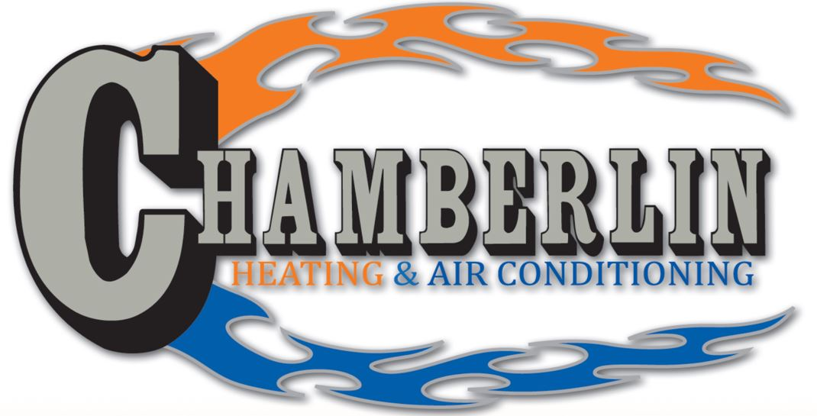
17 POINT FIREPLACE SERVICE/ INSPECTION
- Clean Glass Inside and Out
- Inspect Gasket Seal
- Inspect and Vacuum Logs with Soft Bristle Attachment
- Replace Embers
- Add Lava Rock if Needed
- Test Gas Pressure if Needed
- Inspect Burner Performance
- Clean and Inspect Firebox
- Clean the Outside of the Firebox
- Clean and Inspect Fan
- Vacuum Heat Chamber
- Check for Gas Leaks
- Check Outside Vent
- Check for Carbon Monoxide Leaks
- Check Wall Switch (if applicable)
- Check Burner Ignition
- Run Fireplace to Inspect Flame Quality

Customer:___________________
Address:_____________________
Date:_______________________
Make:______________________
Model:______________________

